Aim: Configure wired and wireless network

# Requirements:

* Window operating system
* Cisco software
* 1 router
* 1 switch
* 2 pc
* 1 laptop
* 1 smart phone
* Ap-pt (Access point-pt)
* Straight through

Step 1: Go to the Cisco and take 1 router, 1 switch, 2 pc, 1 laptop, 1 smart phone and Ap-pt Wireless device.

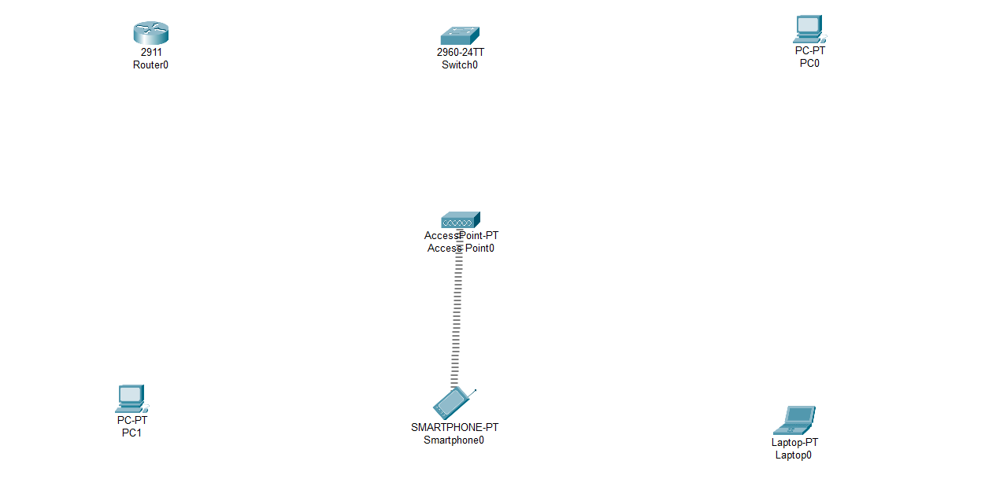

Step 2: Do connection with the help of straight through as follow.

* Router to Switch
* Switch to pc
* Switch to Ap-Pt

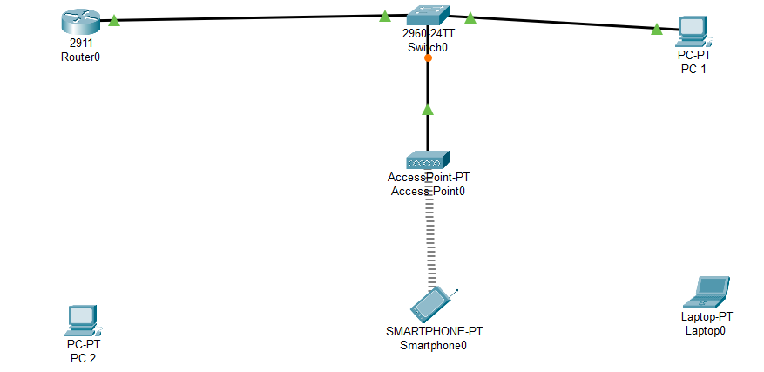

Step 3: Go to the desktop then go to the ip conf. and give the ip address as follow.

Gateway 10.0.0.1

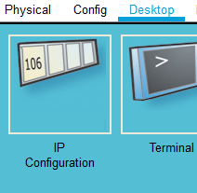

* Router—10.0.0.1 (gig0/0)

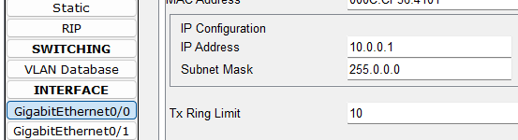

* Pc 1 -- 10.0.0.2

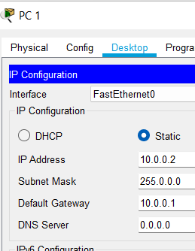

* Pc 2 -- 10.0.0.3

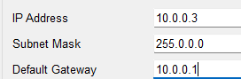

* Laptop – 10.0.0.4

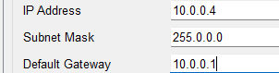

* Smart phone – 10.0.0.5

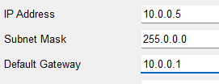

Step 4: know go to the pc 2 and laptop physical.

Then turn off the both machine and change the lan connector to WMP300N.

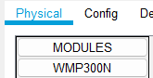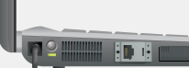

WMP300N



Know turn on the pc and laptop.

Step 5: Know go to the Ap-pt wireless. Then go to the config.

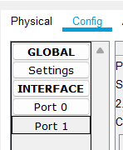

Step 6: go to the port 1 and give the SSID name with the wep key.

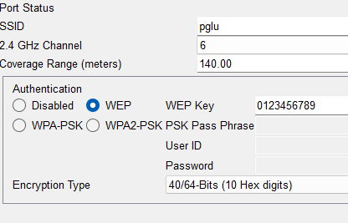

Step 7: Follow these points into the wireless device. ( pc 2, smartphone and laptop)

* Go to the desktop then go to the pc Wireless

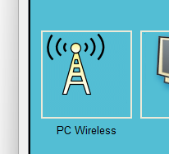

* Then go to the connect and refresh here you can see the ssid wireless network pglu just click on.

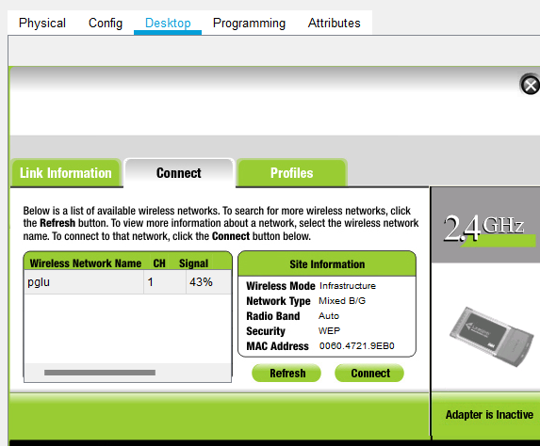

* Then click on connect and fill the key 0123456789 know you are connected to the wirelessly.

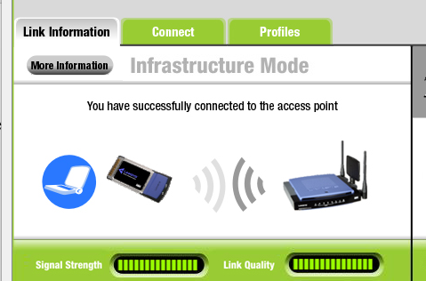

Step 8: know we are connect to wire and wireless.